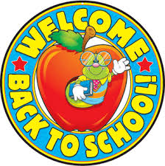TK Newsletter

August 25, 2023

Dates to Remember

* Friday, September 1st- is a **minimum day** for the whole school and a **Mass Day.**

TK will be dismissed at 11:45 AM. Formal uniform means students can only wear red school sweatshirts or Dennis red cardigans for mass if needed.

Class Information

WELCOME to all TK parents and students!

Our first week of school is complete and we have explored the room, toured the school, met our new PE teacher-Mr. Peterson, technology teacher- Mrs. Nelson, our Principal-Ms. Kochis, Vice-Principal-Mrs. Paine, and our school secretary-Mrs. Yandell!

Cl

Book Themes

Themes: School Days

Making Friends

Sharing and Helping



Our Work

Religion: We learned about our patron Saint Ignatius and how he came to be a follower of Jesus. We are also learning 3 prayers: The Lord’s Prayer, St. Ignatius Prayer, and our snack prayer.

Math: We got our math bags and have been practicing making our numbers starting at the top!

Reading: We reviewed our letters and started our letter book Cc and are learning how to find page numbers at the top of the book.

Social Studies/Science: Students were interviewed about themselves.

Other Information

~ Our class has 20 students. The break down is 11 girls and 9 boys!

~To be a helper/volunteer at school, in any capacity, all forms must be completed and turned into the school office.