TK Weekly Newsletter

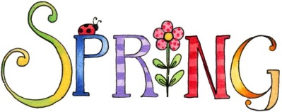 Date March 10, 2017 

Dates to Remember

* Friday, March 17th – St. Patrick’s Day party

10:30-11:30



Classroom News

Students are working on their writing skills. Last month they wrote about whether they would like to have a beard like Lincoln or a wig like Washington. This month they wrote about what they like to do when it rains.

What we have learned

Religion: Students have started working in their Lenten booklets.

Reading: Started working in letterbook B, visualizing the difference between making a lowercase b and d - b: bat and ball, d: dish and knife- which refers to when you make the straight line and circle.

Math: Using counters with our teens.

Science/Social Studies: Planted seeds- waiting and watching to see what and when they will grow.

Other Information

On Friday, March 31st there will be a Talent show and TK will be doing a class act. I will let you know about the time.

Book Themes

Themes**:** Spring

Letter B Books

 