 Date May 5, 2017 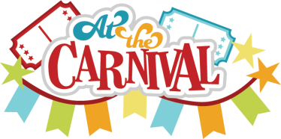

TK Weekly Newsletter

Dates to Remember

* Starting Monday, May 8th-May 12th- Book Fair in the Library
* Wednesday, May 10th –

May Crowning Mass/If needed – Red Sweatshirts/Cardigans only

* Friday, May 12th – 8Th Grade Carnival 11:30-2:45 and

Free Dress!





Classroom News

At next Wednesday’s mass each student is asked to bring one fresh flower. Each class will process into the church and have a flower to lie at the feet of our Blessed Virgin statue. The last class to enter the church will be the Second Graders who have received their First Communion. As always, parents are welcomed at mass!

What we have learned

Religion: Learned the “Holy Family” is Mary, Joseph and Jesus. Jesus’ name means “God Saves.” God chose Mary to be Jesus’ mother and God chose Joseph to take care of them.

Reading: Finished letterbook V and started on letterbook W.

Math: Working on numbers 20-30.

Science/Social Studies: Talked about parts of plants and their jobs and Cinco de Mayo.

Other Information

Please don’t forget to sign out your student next Friday if you leave before 2:45. I just need to know who to round up for Extended at the end of the day.

Book Themes

Themes**:** W books, Cinco de Mayo

