EASTER EGG
HUNT
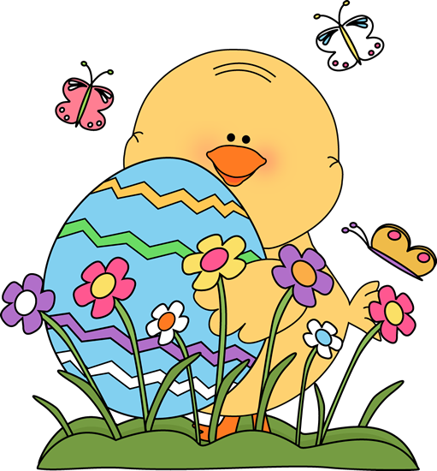
Please bring 6 filled plastic eggs to school by Friday, March 31st
* NO peanut products & NO chocolate
* Good ideas to fill eggs with are STICKERS, bouncy balls, Jelly beans…

