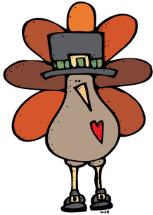 Date November 3, 2017 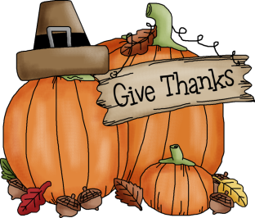

TK Weekly Newsletter

Classroom News

We are moving into our Thanksgiving unit and will be making turkeys, Indian corn, and pictures of what we are Thankful for to decorate our boards and walls for the month of November.

Dates to Remember

* Sunday, November 5th is the end of Daylight Savings-
* Wednesday, November 8th, Dress-4-Funds $2.00
* Friday, November 10th , NO SCHOOL-

Veterans Day Holiday

Our Work

Religion: Discussed what a Saint is and who some of the more famous ones are: St. Francis of Assisi, St. Patrick, and St. Nicholas

Reading: Finished letter book S and will start letter book L

Math: Working on 1 to 1 correspondence and patterns.

Science/Social Studies: In our Let’s Find Out magazine watched a short video on bats and the many things that they can do.

Other Information

Going home today is information about the 8th grade spaghetti dinner, the March Gala – the Pirate’s Ball, and an order form for logo wear from the Athletics. Please note Gala information went home with the oldest student in the school.

Books we've read

Themes: S books

Thanksgiving

